As AI Eats Web Traffic, Don’t Panic—Evolve
An SEO expert offers three tips for adapting to “zero click” searches and chatbots.
Based on insights from
Kelly Cutler
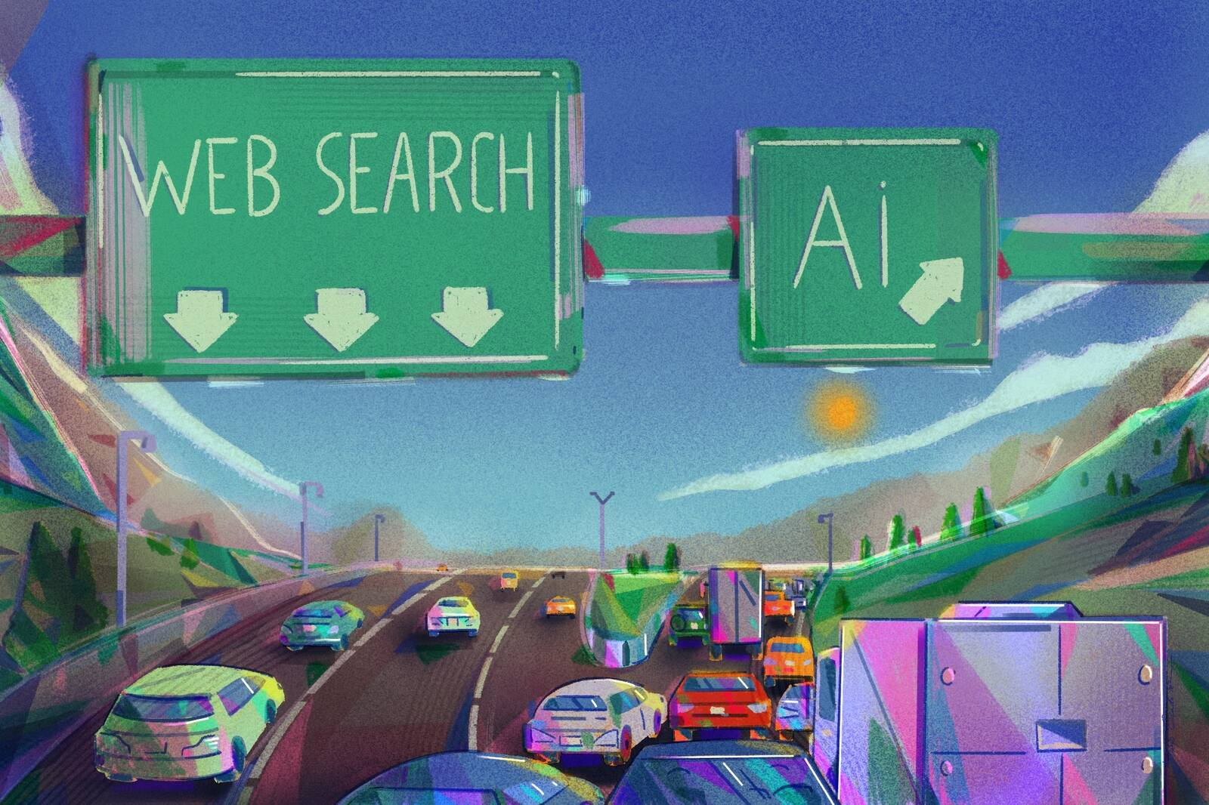
Jesús Escudero
Summary The rise of AI chatbots and “zero click” searches has taken a big bite out of the traffic for many websites in 2025. But a digital-marketing expert says that companies and publishers can adapt by sticking with established search-e... more
For many websites, 2025 has been a rude awakening to the AI era. Retailers, news publications, and marketing agencies saw drops in traffic of 20–40 percent, with much of that decline coming from a loss of organic search traffic. The likely culprit: the new AI-generated summaries appearing at the top of search results, providing many users with the answer they sought without any additional clicks.
But Kelly Cutler, an associate professor at the Medill School of Journalism and lecturer in the Kellogg Executive Education program, says that the search reset is merely the latest seismic shock in an always-changing internet ecosystem.
“This industry has seen these shifts many, many times throughout the last 20–25 years,” Cutler says. “So this is not something where I would be panicking or assuming that SEO is dead or search engines are over. The sky is not falling. It’s okay, but marketers need to evolve.”
As such, businesses and publishers will need to reexamine their strategies and adapt to the ways AI is changing search, much as they did for the rise of Google or the growth in mobile browsing.
From focusing on new metrics and SEO strategies to pushing hard into personalization and alternative sources of traffic, it’s time to experiment, Cutler says.
“Engagement is changing,” she says. “I know that’s not what anyone wants to hear, but it’s a fact. I do think in some ways this brings us back to where we should be, which is that it’s all about the user.”
Here are three tips for navigating the new search environment.
Track more-nuanced metrics
Beneath the alarming dip in search traffic, some sites have reported a silver lining: while fewer people are visiting, those who end up on a site are more engaged. For retailers, that means higher conversions to sales; for content publishers, that means more articles read or videos watched.
If AI summaries are detouring visitors by providing the “easy answers” that previously drove a lot of casual web-browsing, the remaining traffic is at least made up of more-motivated customers, Cutler says.
“What many of my clients are seeing is that impressions and conversions are actually up, even though clicks may be down,” Cutler says. “Quality is up, which is great. So you have to take the baby with the bathwater. You can’t toss it all out. You have to really investigate deeper.”
One key realignment Cutler suggests is to stop obsessing over clicks and refocus on deeper metrics. Measures such as time on page and user journeys within the site have always been a more-nuanced measure of a site’s true success than raw clicks—and they matter even more in the new era of AI search.
“Tracking engagement metrics is key,” Cutler says. “Once people come to the site, how long do they spend? What do they do? How are they interacting with your content?”
Because Google remains the leading search engine by far, most of these tools should be familiar to people who have been using Google Analytics for years to monitor traffic, she says.
“There’s a lot of opportunity for marketers who have the data, who are looking at Google Search Console on a regular basis to understand how their traffic’s changing, so they can be nimble and agile and try things.”
Adjust your SEO strategies
For decades, websites have pursued traffic through a variety of SEO strategies. From tailoring headlines and keywords to installing backend plugins, these approaches were meant to raise a site’s visibility on Google and other search portals, drawing in more visitors.
But as “zero click” searches—where users get their answer from an AI summary or response instead of clicking a link—take a big bite out of website traffic, there’s a new game in town: GEO, or generative engine optimization. Despite the new acronym, Cutler says that GEO is in many ways a continuation of classic SEO principles.
“It’s a new version of SEO that really takes into account the fact that we are absolutely going to see these dips and other AI companies coming into play and taking some of Google’s traffic,” she says. “It’s a way to optimize to be included in the AI answers or AI overviews.”
The general idea is, if you can’t beat ’em, join ’em. By making your content more likely to be used in an AI summary, readers who want to know more may find themselves clicking through to your site anyway as they dig into the references provided by the model.
“Budget for testing and learning and optimization. I think that’s key right now, because we don’t know what we don’t know, so we’ve got to try things.”
—
Kelly Cutler
In these early days of AI search, it’s not yet clear why and how these models decide to use certain types of content in their replies. Frameworks like Google’s E-E-A-T guidelines—experience, expertise, authoritativeness, trustworthiness—probably still hold up for anticipating what search engines and their newer AI tools will prioritize, Cutler says.
But specifically optimizing for large language models will be important in the future, which means a focus on driving content visibility in AI-driven searches, not just on search-engine results pages. That creates a “new Wild West,” where it’s important to experiment.
“The biggest case I make right now with my clients is to budget for testing and learning and optimization. I think that’s key right now, because we don’t know what we don’t know, so we’ve got to try things.”
One company advised by Cutler used an AI-powered optimization tool that guided them to adjust keywords and structure in their content, increasing their appearances in Google’s AI Overviews by 61 percent. As a result, they saw increases in blog impressions and clicks despite the industry-wide drop-off in traffic.
“They’re piloting new tools to see how they can breathe new life into SEO,” Cutler says. “They’re absolutely not giving up on SEO in any way.”
Lean into personalization
With organic-search traffic in decline, companies should also expand their approach to customer targeting, Cutler says. While not new, paid search and social media continue to be effective ways to reach out to specific audiences—and AI is making those tools even better at finding users based on age, location, occupation, intent, and other characteristics.
But the real untapped potential may lie in thinking beyond segmentation to get even more granular, giving every potential reader or customer exactly what they want.
“People expect more personalization,” Cutler says. “They’ve been trained by Netflix and Spotify and all of the platforms they use every single day that allow them to create a very curated, personalized experience.”
Along these lines, increasing engagement may mean reaching people in their inbox instead of their search engine.
“Personalization is a huge opportunity with email marketing, particularly newsletters, where you can really create opportunities for personalized messaging and provide dynamic content for users based on their preferences, their behaviors, and the data that you have.”
Beyond customizing content, websites should also consider providing it in different formats instead of a one-size-fits-all style. Readers may trust your site over opaque or bland AI summaries, but only if they can find it at the level of detail they desire. Some may prefer just a few sentences or bullet points, while others may delve deeper into lengthy primary sources or prefer video content.
This, too, hearkens back to E-E-A-T best practices, which emphasizes a mix of content that conveys expertise and thought leadership across multiple modalities—audio, video, and text—and in diverse forms such as testimonials, case studies, interviews, product reviews, demonstrations, FAQs and more.
But even if users don’t click through from AI summaries or personalized newsletters, Cutler thinks adapting to this new era of optimization might just mean getting back to the original purpose of websites: connecting people with information.
“We’re so used to the goal and objective being traffic to the site. But I really believe that may not be the end all, be all,” she says. “At the end of the day, I’m trying to help people. So when I can get them information that’s interesting to them, that helps them move along that journey that they’re on, that’s a good thing for me.”
About the Writer
Rob Mitchum is editor-in-chief of Kellogg Insight.

